This year families will be able to register online or in person.
In person Registration Information:
Please visit the Youth Center located at 1780 E Hill St. Registration opens at 8am

- Proof of residency will be required from July 30 -August 6 for Signal Hill residents (Bill, insurance, ID, etc.)
- Please have your registration form completed and signed. This includes:
- ARC Registration Form
- Signed Parent Handbook

- Please be ready to make a payment
- An annual $25 Youth Registration Fee is due
Online Registration Information:
Please note: Registration access is more user friendly using a tablet or computer.
- Click on the following link: https://secure.rec1.com/CA/signal-hill-ca/catalog

- Log in to your CivicRec account using your email. If you do not have an account you will need to create one and add your child(ren).

- Select Youth Programs at the top of the page.

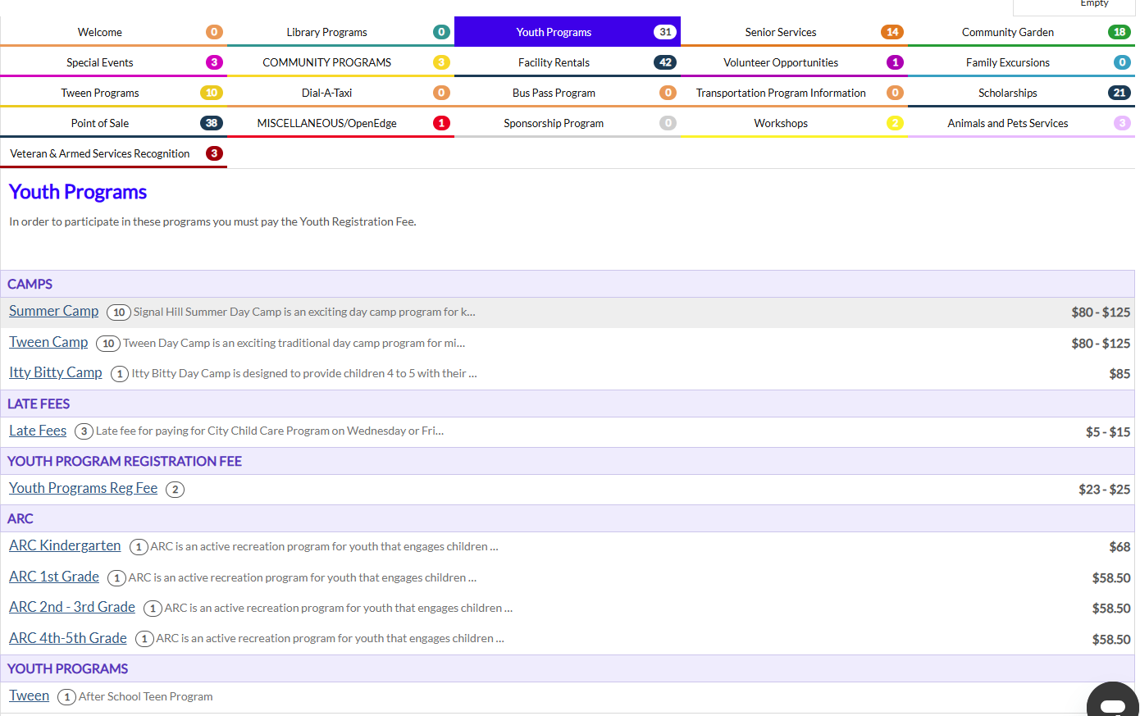

- Click on the grade level of your child
Example: ARC 2nd -3rd Grade

- Select the child or children you would like to register by clicking on the square to the left of their name and Add To Cart.
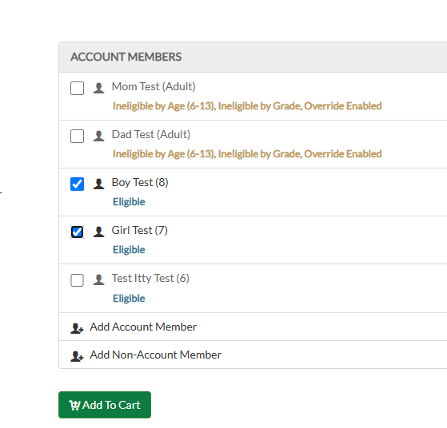

- Click on Checkout on the bottom left.
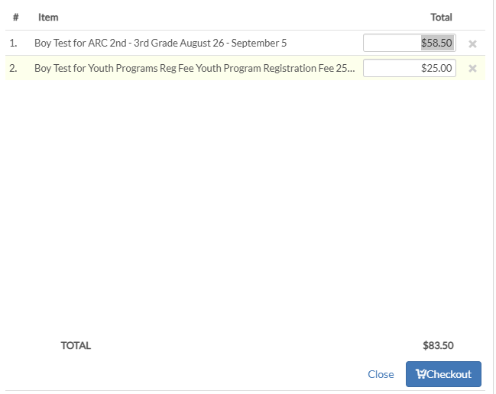

- Select Credit/Debit and enter payment information.
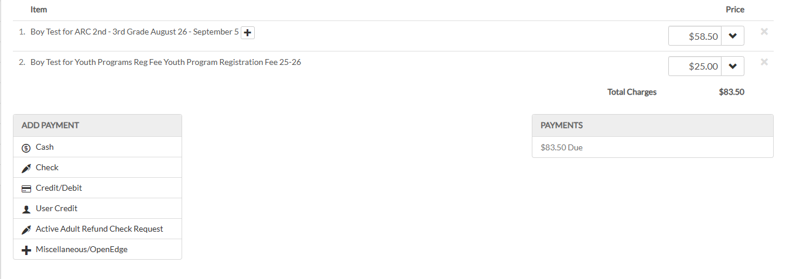
After registering you will be contacted to provide the following:
- Proof of residency between July 30 -August 6 for Signal Hill residents (Bill, insurance, ID, etc.) Please Note: If you do not provide this information within 3 days of registering, you could be dropped from all the sessions you enrolled in.
- Registration Form
- Signed Conduct Code
- Signed Parent Handbook
Once we have received all of the above documents, your registration is complete.

