City of Signal Hill

2175 Cherry Avenue Signal Hill, CA 90755-3799

NOTICE OF PREPARATION OF AN ENVIRONMENTAL IMPACT REPORT
TO: California State Clearinghouse; California Responsible and Trustee Agencies; Other Interested Public Agencies; and Interested Parties and Organizations
SUBJECT: Notice of Preparation of a Draft Environmental Impact Report for the Signal Hill Petroleum Conditional Use Permit 97-03 Extension Project
DATE: January 13, 2023
The City of Signal Hill (City), as lead agency under the California Environmental Quality Act (CEQA), will be coordinating the preparation of an Environmental Impact Report (EIR) for the proposed 20-year extension of Signal Hill Petroleum’s (SHP) Conditional Use Permit (CUP) 97-03, which is further described below. The City is requesting identification of environmental issues and information that you or your organization believes should be considered in the EIR. A complete project description and Initial Study is attached to this Notice of Preparation to facilitate your review during the scoping period.
PUBLIC REVIEW PERIOD: January 13, 2023 to February 11, 2023
NOTICE OF SCOPING MEETINGS: Pursuant to California Public Resources Code Sections 21081.7, 21083.9, and 21092.2, the City of Signal Hill will conduct a scoping meeting for the purposes of soliciting oral and written comments from interested parties requesting notice, responsible agencies, agencies with jurisdiction by law, trustee agencies, and involved federal agencies, as to the appropriate scope and content of the EIR.
SCOPING MEETING: The City will hold a hybrid, virtual and in-person scoping meeting for the Proposed Project to receive comments on the scope and content of the proposed EIR. You are welcome to attend the meeting and present environmental information that you believe should be considered in the EIR. The scoping meetings are scheduled as follows:

Date: January 30, 2023
Time: 6-8pm
Place: Signal Hill City Hall, Council Chamber, 2175 Cherry Ave.
Zoom Meeting Link: https://us02web.zoom.us/j/86762745388?pwd=K2ExZ1FzeGh3bnQxTDNyUDFLV3N1dz09
AGENCIES: The City requests your agency’s views on the scope and content of the environmental information relevant to your agency’s statutory responsibilities in connection with the Proposed Project, in accordance with the California Code of Regulations, Title 14, Section 15082(b). Your agency may need to use the EIR prepared by the City when considering any permits that your agency must issue or other project approvals.

PROJECT LOCATION: The project is located entirely within the City of Signal Hill, in Los Angeles County, California (Figure 1). SHP currently operates seven oil and gas drill sites located throughout the City of Signal Hill (City) under one consolidated Conditional Use Permit (CUP) (Record No. 97-03). The Project area includes the seven existing sites located throughout the City within the West, Central, and East units of the Long Beach Oil Field (Figure 2). The sites are located within developed urban areas, adjacent to lands designated for industrial, commercial, and residential uses.
PROJECT BACKGROUND
Prior to SHP acquisition, the various drill sites throughout the City of Signal Hill were owned by ARCO, Shell, and Texaco and each site was operated under a separate CUP. SHP began acquiring drill sites in 1984, and once they acquired all seven drill sites, the City consolidated the CUP to cover all sites under one permit, CUP 97-03. On June 16, 1998, the City Council first approved CUP 97-03 and the related Initial Study-Mitigated Negative Declaration (IS/MND), pursuant to CEQA. CUP 97-03 allowed SHP to continue their oil and gas well drilling activity and production, storage, processing, and shipping of materials at the seven sites. The 1998 CUP approval also included 18 conditions of approval (COAs), including an annual review by the City through an inspection by the Oil Services Coordinator, and an initial approval term of 5 years. The CEQA IS/MND also contained 14 mitigation measures, which were incorporated into the CUP COAs. The CUP has been amended and renewed multiple times since it was first issued in 1998. Most recently, the City renewed the CUP for a 2-year term in July 2021 which expires on July 30, 2023.
THE PROPOSED PROJECT
Pursuant to the CEQA, Public Resources Code, Sections 21000 et seq., the City is initiating preparation of an EIR to evaluate and disclose the potential impacts associated with its discretionary decision to approve, approve with conditions, or disapprove of SHP’s request to extend CUP 97-03 for 20 years.
SHP is requesting a permit extension of 20 years for CUP 97-03 to continue their existing oil and gas production, storage, processing, and shipping of materials at the seven CUP drill sites. The Project would not significantly alter or expand the scope of their existing oil and gas operations under CUP 97-03. All operations (existing and proposed) would continue to occur within the existing permitted CUP footprint. SHP proposes to install new equipment at the existing natural gas processing facility at CUP Drill Site #2 and drill up to 46 new wells at the seven drill sites. All other operational activity, such as site maintenance, inspections, redrilling and well operation, and fluid processing would remain the same. SHP would continue to operate the CUP facilities (Drill Sites and Central Processing Facilities) in accordance with the existing City Municipal Oil and Gas Code, conditions of approval and mitigation measures, and in continued compliance with existing county, state, and federal requirements, including those published by California Geologic Energy Management Division (CalGEM). SHP would also continue ongoing ‘by right’ oil and gas operations consistent with the City’s Oil and Gas Code (Signal Hill Municipal Code – Title 16) and CalGEM requirements, as applicable.
SHP is seeking to modify CUP 97-03 with the following objectives:
- Extend the life of the CUP by an additional 20-year term, to expire in 2042.
- Continue existing consolidated drill site operations, including drilling new wells within the existing CUP footprint on an as needed basis, to continue providing a local source of high-quality oil, natural gas, and electricity, and install upgrades to a natural gas processing system.
ISSUES TO BE ADDRESSED IN THE ENVIRONMENTAL IMPACT REPORT
Based on the project description and City’s understanding of the environmental issues associated with the proposed Project, it is anticipated that the implementation of the proposed Project has the potential to result in environmental effects associated with some or all of the following resources/topics:

- Aesthetics
- Agriculture Resources
- Air Quality
- Biological Resources
- Cultural Resources
- Energy
- Geology and Soils
- Greenhouse Gases
- Hazards and Hazardous Materials
- Hydrology and Water Quality
- Land Use and Planning
- Mineral Resources
- Noise
- Population and Housing
- Public Services
- Recreation
- Transportation/Traffic
- Tribal Cultural Resources
- Utilities, Energy and Service Systems
- Wildfire

DOCUMENT AVAILABILITY: The NOP can be viewed on the city website at www.cityofsignalhill.org. Future project documents, including the EIR, will also be made available at this website.

SUBMITTAL OF WRITTEN COMMENTS: The City is soliciting comments regarding the scope, content, and specificity of the EIR from all responsible agencies, agencies with jurisdiction by law, trustee agencies, involved agencies, and interested parties requesting notice. Please send your written/typed comments to the City by one of the following delivery methods. In your comments, please include your name, email address, telephone number, address, and an RE: Signal Hill Petroleum CUP 97-03 Extension EIR at the top of your comment.
Email: cdoan@cityofsignalhill.org
Post: Colleen Doan
Community Development Director
2175 Cherry Avenue
Signal Hill, California 90755

In accordance with CEQA Section 15082, this Notice of Preparation is being circulated for a 30-day comment period; the City requests that written comments be provided at the earliest possible date, but no later than 5:00 p.m. on February 11, 2023.
Colleen T. Doan
Colleen Doan
Community Development Director
(562) 989-7344
CDoan@cityofsignalhill.org
Figure 1. Project Vicinity Map
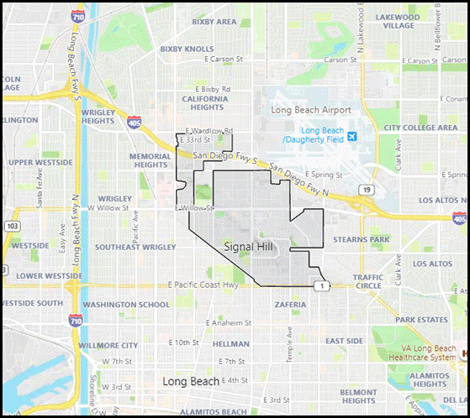

Figure 2. CUP Sites
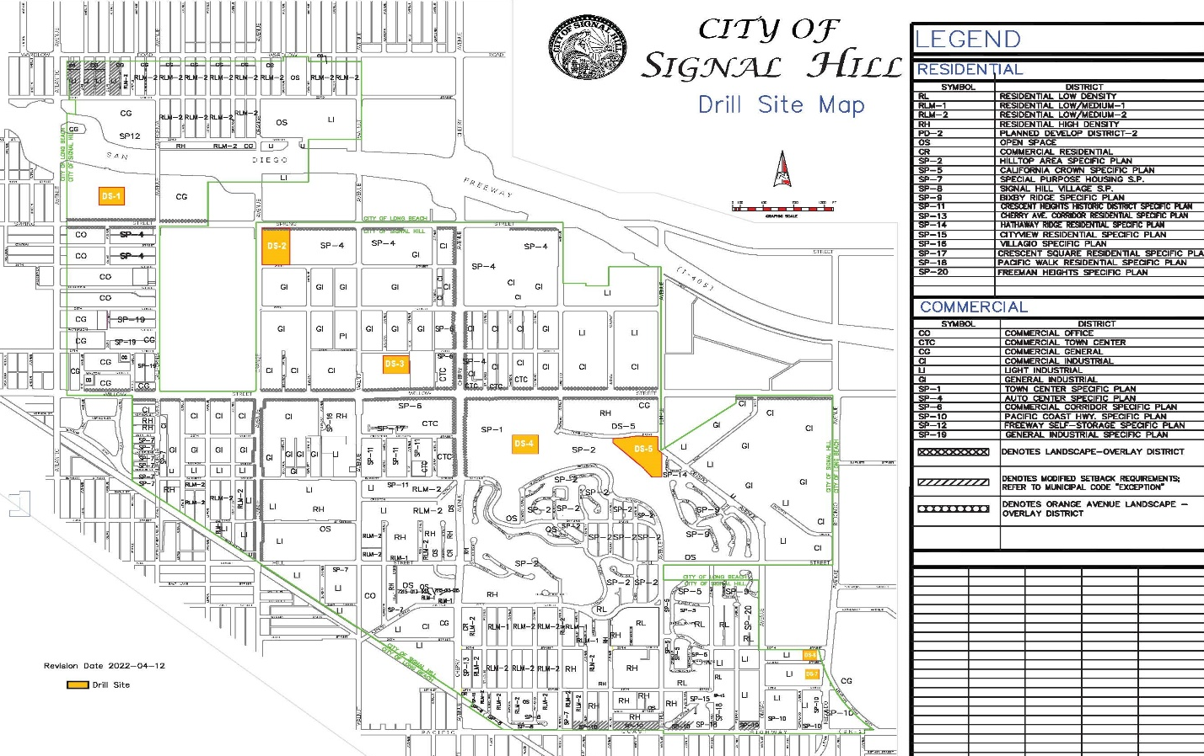

Attachment 1. CEQA Initial Study

